Brief summary of Chapters and procedures and formula – Applied Maths
From Oliver Murphy’s Fundamental Applied Maths

Uniform Acceleration:
$v=u+at$
$s=(\frac{u+v}{2})$
$s=ut+\frac{1}{2}at^{2}$
$v^{2}=u^{2}+2as$
- Using time-velocity graphs.
Area under time-velocity graphs = distance travelled.
- Problems which lead to Linear Equations.
- Problems which lead to Simultaneous Equations.
- Problems with only acceleration and deceleration.

Where there is acceleration followed by immediate deceleration let v = top speed, then find in terms of v:

- The time spent accelerating.
- The time spent decelerating.

Then solve for v etc.

Draw graphs for when there is a speed limit or not.
- Problems involving two objects.

One not accelerating – Let u = the speed of particle 1 as it passes P if not given
it. At overtaking, both have travelled the same distance from a point. Find the distance for both $s=ut+\frac{1}{2}at^{2}$ and equate to find t.

Both accelerating – The greatest gap between them will occur when their
speeds are the same.
Use $v=u+at$ for both if possible and then let $v_{1}$= $v_{2}$ and solve for t etc.

Note – if acceleration changes, you cannot use $s=ut+\frac{1}{2}at^{2}$ for the
entire motion. Use a time – velocity graph.

- Motion under gravity.
- g = 9.8 $m/{s^{2}}$
- During (for example) the 3rd second is from t = 2 to t = 3 seconds.
- If a particle travels exactly 30m in the 3rd second, then it’s speed is 30 $m/s$ exactly at 2.5 seconds since acceleration is constant.

- If letters are used instead of numbers, imagine what you would do if you had numbers and just do the same thing.

Projectiles:

- Projectiles launched Vertically.
- Projectiles launched at an angle.
Gravity will affect the j velocity only. The i velocity remains unchanged.
- When speed and angle are known.
The range is twice the distance to maximum height (No air resistance)
- Using the formula from the previous chapter to solve projectile problems.
$$v_{x}=u_{x}$$
$s_{x}=u_{x}t$
$v_{y}=u_{y}-gt$
$$s_{y}= u_{y}t-\frac{1}{2}gt^{2}$$

Find each of these in terms of t. There is no acceleration in the x direction.
Remember that magnitude is $\sqrt{a^{2}+b^{2}}$ for a vector $ai+bj$.
At the maximum height $v_{y}=0$.
- Maximum Range.

Derive these formula:
The greatest height = $\frac{u^{2}{\left(\sin{∝}\right)}^{2}}{2g}$
Write out $v^{x}$, $s_{x}$, $v_{y}$ and $s_{y}$.
Use $v^{2}=u^{2}+2as$. At the greatest height $v_{y}=0$ etc.
The range = $\frac{u^{2}\sin{2∝}}{g}$
Use $s=ut+\frac{1}{2}at^{2}$. At the maximum range $s_{y}=0$. Find the 2 times when $s_{y}=0$. One will be zero. Use the other one. Insert it into $s_{x}=u\cos{∝t}$ since we want to find the distance in the x direction.
When finding the maximum range use $\sin{2A}=2\sin{A}\cos{A}$
The range will be a maximum when $∝={45}^{0}$

- Target Practice.
Use $\tan{A}=\frac{\sin{A}}{\cos{A}}$ and $\frac{1}{{\left(\cos{A}\right)}^{2}}=1+{\left(\tan{A}\right)}^{2}$ to get a quadratic
in Tan (A)

Newtons Laws and Connected Particles:

Force: is what causes an object to accelerate. It is a vector quantity.
A force of 1 Newton causes a particle of mass 1 Kg to accelerate $1m/{s^{2}}$
Momentum: is mass of an object multiplied by its velocity. It is a vector quantity.
Newtons Laws of motion:
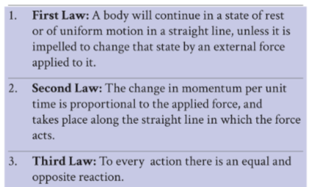

Normal reaction: a force perpendicular to the surface of contact.
Friction: a force in the opposite direction to motion caused by contact between the
object and the surface.
$F=μR$
Where F is the magnitude of the friction force, $μ$ is the coefficient of friction and R is the magnitude of the Normal Reaction between the object and the surface.
When resolving forces draw the original force, then its components differently i.e., as dotted lines or in a different colour.

Systems of connected particles:
Draw separate force diagrams for each particle. Positive direction is determined by the acceleration.
If a pulley P is pulled up by “two” (same string wrapped around the pulley) strings and a mass Q is pulled down by one string (same string), the velocity and acceleration of the mass will be twice that of the pulley.
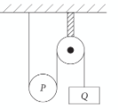
Particles on slopes:
Resolve forces parallel and perpendicular to the relevant slope.

Work, Power, Energy and Momentum:

Work and Power:
For a constant force
Work = Force x Distance
Work is a scalar quantity and is measured in Joules (J).
1 Joule is the work done when a force of 1 Newton is applied over a distance of 1 metre. (It is a newton-metre)
Power is the rate at which work is done i.e., work done per unit time.
Power is a scalar quantity measured in watts. 1 watt = 1 joule per second.
Power output P = Tv where T is the forward driving force of trains or cars.

Drag Forces:
Drag forces are the forces due to resistance when a body travels through a fluid e.g., through air or water
$D=kv^{2}$ or $D=kv$ or $D=kv^{n}$ depending on the circumstances.
Remember that at maximum speed, acceleration must be zero and the resultant forces must be zero.
Energy:
Energy is the capacity of a body to do work.
Potential energy is the energy that an object has due to its position.
Potential energy = mgh
Kinetic energy is the energy that an object has due to its speed.
Kinetic energy = $\frac{1}{2}mv^{2}$
The Principal of Conservation of energy:
Applies when the only forces which do work are gravitational forces.
$mgh+\frac{1}{2}mv^{2}=constant$
${KE}_{1}+{PE}_{1}={KE}_{2}+{PE}_{2}.$
Very often we use: $\frac{1}{2}mu^{2}+mgh_{1}=\frac{1}{2}mv^{2}+mgh_{2}$
Conservation of momentum:
When two particles collide.
Momentum is the product of mass and velocity. It is a vector quantity along the line of the velocity. Its units are $Kg m/s$
The Impulse imparted on a body is the change in its momentum.
$\vec{I}=m\vec{v}-m\vec{u}$
If no external forces act on a system, the total momentum before = the total momentum after impact.
$m_{1}{\vec{u}}_{1}+m_{2}{\vec{u}}_{2}=m_{1}{\vec{v}}_{1}+m_{2}{\vec{v}}_{2}$
Conservation of momentum in two dimensions:
Conservation of momentum as it applies to strings:
Draw separate force diagrams for each particle.
Impacts and collisions:

Impacts:
The coefficient of restitution $-e=\frac{v}{u}$ i.e., $\frac{new velocity}{old velocity}$
When a sphere impacts a smooth horizontal surface at an angle and rebounds, the $\vec{j}$ component will be affected and the $\vec{i}$component will remain unchanged.
Direct Collisions:
When two particles are moving in the same direction before and after the collision.
Newtons Law of Restitution (NLR):
$-e=\frac{v_{1}-v_{2}}{u_{1}-u_{2}}$
No external forces act on the system so the Principal of Conservation of Momentum applies i.e.
$m_{1}{\vec{u}}_{1}+m_{2}{\vec{u}}_{2}=m_{1}{\vec{v}}_{1}+m_{2}{\vec{v}}_{2}$
Draw a table including Velocity Before Mass Velocity After
Use both formula above to form 2 equations and solve.
Oblique Collisions:
When two smooth spheres collide at an angle to one another. The $\vec{j}$ velocities remain unchanged since they impact along the $\vec{i}$ direction.
Take the line joining their centres at the moment of impact as the $\vec{i}$-axis.
PCM and NLR apply also in these questions.
Draw a table including Velocity Before Mass Velocity After
Use both formula above to form 2 equations and solve.
To find the angle of deflection you can use the following (Page 17 tables)
$\left|{\vec{v}}_{1}\right|=\sqrt{x_{1}^{2}+y_{1}^{2}}$
$\cos{θ}=\frac{\vec{u}\vec{.v}}{\left|\vec{u}\right|\left|\vec{v}\right|}$

Harder Examples:

Projectiles which bounce:
If a particle has velocity ${\vec{v}}_{l}=p\vec{i}-q\vec{j}$ and hits a smooth horizontal surface then its take-off velocity will be
${\vec{v}}_{l}=p\vec{i}+eq\vec{j}$
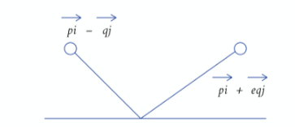
If a particle has velocity ${\vec{v}}_{l}=p\vec{i}+q\vec{j}$ and hits a smooth vertical surface then its take-off velocity will be
${\vec{v}}_{r}=-ep\vec{i}+q\vec{j}$
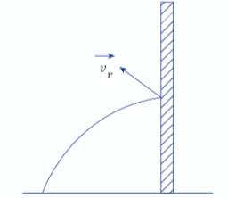

Motion in a Circle:

Radian Measure:
$The angle \left(in Radians\right)=\frac{Length of arc}{Length of radius}$
$Arc length l=rθ$ (Page 9 of the tables)
When converting from radians to degrees and visa-versa use
$π radians={180}^{0}$
Radians per second is called angular speed, usually denoted by the letter $ω$. Page 51 tables.
$v=ωr$ where r is the radius of the circle and v is the particles linear speed in $\frac{m}{s}$

Centripetal acceleration:
You need to be able to prove the following formula
Centripetal acceleration = $\frac{v^{2}}{r}=ω^{2}r$ Page 51 tables.
Motion in a horizontal circle:
$F=\frac{mv^{2}}{r}=mω^{2}r$
$F_{up}=F_{down}$
Resolve forces in to their horizontal and vertical components.
Harder examples:
Motion in a vertical circle:
Resolve forces along the perpendicular to the radius to make one
equation and use the energy equation
$mgh_{1}+\frac{1}{2}mv_{1}^{2}=mgh_{2}+\frac{1}{2}mv_{2}^{2}$
(Starting point) (At a later point)
Note: when a string just slackens, T = 0.
Or when a particle just leaves a smooth sphere, R=0.
Hooke’s Law:
$F=-ks$ Page 57 of the tables.
Where F the force at the end of a string, k (in N/m) is the elastic constant and s is the distance that the elastic string is extended beyond its natural length.
We very often use: The magnitude of a force $F=k(l-l_{0})$
Where l is the actual length, $l_{0}$ is the natural length and k is the elastic constant.
If a particle is hanging vertically from an elastic string in equilibrium, then $F_{Up}=F_{Down}$

Difference Equations:

First and Second Differences:
Use formula on page 22 of tables.
For linear sequences $T_{n}=an+b$ the first differences are constant.
For quadratic sequences $T_{n}=an^{2}+bn+c$ the second differences are constant.
Recurrence Relations:
Functions that can be determined as a function of the previous term or terms. We need previous terms to work out any term.
Difference Equations:
If we are given a recurrence relation we can define $T_{n}$ in terms of n.
This is solving a difference equation.
Solving First-Order Difference Equations:
Each term is defined in terms of just one previous term, the term before it.
Make 3 equations and to see the pattern.
Then using $S_{n}=\frac{a\left(1-r^{n}\right)}{1-r}$ form the solution.
When a sequence approaches a limit, the population reaches a steady state. In this case $P_{n+1}=P_{n}$
Interest Repayments:
Ties into the Amortisation formula from the other Maths course.
Second Order-Homogeneous Difference Equations:
Any term is defined using only the previous two terms.
Homogeneous – only $T_{n }and T_{n+k} or T_{n-k}$
Non-homogeneous (inhomogeneous) – Not only $T_{n }and T_{n+k} or T_{n-k}$
First solve the associated characteristic equation.
If $α and β$ are the two roots of the characteristic quadratic equation $px^{2}+qx+r=0$then the solution to the second-order difference equation $pu_{n+2}+q_{n+1}+ru=0$ will be of the form $u_{n}=lα^{n}+mβ^{n}$
If $α and α$ are the two roots of the characteristic quadratic equation $px^{2}+qx+r=0$then the solution to the second-order difference equation $pu_{n+2}+q_{n+1}+ru=0$ will be of the form $u_{n}=lα^{n}+mnα^{n}$

Inhomogeneous Difference equations:
There are two parts to the solution. They are the particular solution and the complementary solution. The final solution is the sum of these.
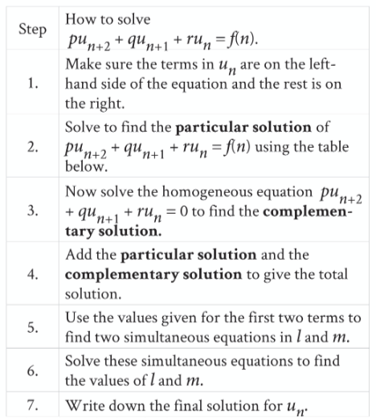
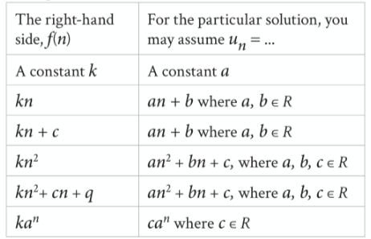

Differentiation and Integration:

Logarithms:
Page 21 of the tables
Rules for Integration – page 26 of the tables.
Indefinite Integrals:
Don’t forget the constant of integration c.
Definite Integrals:
No need for c.
Integration by parts:
$\int{udv=uv-\int{vdu}}$
Use the INLATE rule: Inverse, Logs, Algebra, Trigonometry, Exponential.
Write down u and dv. Differentiate u and integrate dv.
Two-Steppers:
See the example in the book page 170.
The Chain Rule for Composite Functions:
Page 25 of the tables.
There is no chain rule for composite functions, so we integrate by
substitution. Let u equal the “inner” function and integrate w.r.t.x.
i.e. reduce the function down to a function that you can integrate from your
tables.
Rates of Change:
The instantaneous rate of increase or decrease.
Using Integration:
Differentiate displacement (m) to get Velocity (m/s). Differentiate Velocity (m/s) to get acceleration ($m/{s^{2}}$).
Integrate acceleration$(m/{s^{2}}$) to get velocity (m/s). Integrate velocity (m/s) to get displacement (m).

Differentiating Vectors:
Differentiate the $\vec{i}$ and $\vec{j}$ parts separately.
Work done by a variable force:
Work is what we get when we integrate Force.
i.e., $W=\int_{A}^{B}{F\left(x\right)}dx$
Remember that for elastic strings F = kx so that when we stretch an elastic string from a point $x_{1}$ to a point $x_{2}$ the work done is $\frac{k}{2}\left(x_{2}^{2}-x_{1}^{2}\right)$

Differential Equations:

First-order differential equations: General Solutions:
Separate the equation so that all the terms in y are on one side and all the terms in x are on the other side. Integrate both sides. Put the constant of integration on the right-hand side. Get y on its own. This is the general solution for all values of c.
First-order differential equations: with definite values:
Separate the variables as above. Then put in the limits.
Second-order separable differential equations:
These are differential equations where
$\frac{d^{2}y}{dy^{2}}=f\left(\frac{dy}{dx}\right)$
Let $v=\frac{dy}{dx}$ Then solve for v. Then solve for y.

Solving real-life problems by means of differential equations:
Velocity $v=\frac{ds}{dt}$
There are two ways of writing acceleration
$a=\frac{dv}{dt}$ and $a=v\frac{dv}{ds}$
One relates v and t while the other relates v and s.
Therefore $F=ma=m\frac{dv}{dt}=v\frac{dv}{ds}$
Harder problems:
Some problems require you to use both $a=\frac{dv}{dt}$ and $a=v\frac{dv}{ds}$
Problems involving power:
Power output P = Tv
Problems involving populations, finance, cooling and other non-mechanical fields:
No acceleration or forces.
Differential and difference equations: What’s the difference?
Difference equations are useful when the change is incremental and discrete.
e.g., interest payments made once per month.
Differential equations apply when the change is continuous.
e.g., temperature change in a body.
Draw a force diagram with a scale. Any acceleration or velocity along the positive direction is plus and any acceleration or force along the negative direction is minus.

Networks and Graphs:

Kruskal’s algorithm (Minimum spanning tree):
- List the weights in ascending order.
- Start with the least weights (draw the edge)
- Start the next edge etc.
- Make sure there are no cycles.
- Include all nodes.
- n nodes => n-1 edges.
Prim’s Algorithm (Minimum spanning tree):
- Choose any node.
- Choose the edge of least weight that joins that vertex to another vertex.
- Choose an edge of least weight that goes from a vertex in the tree.
- There should be no cycles.
- Include all nodes.
- n nodes => n-1 edges.

Optimal Paths:

Dijkstra’s Algorithm (Shortest path/Early, Late times):
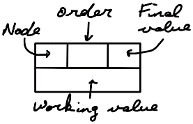

- Start at the source.
- Look at the working values not completed.
- Choose the LEAST uncompleted working value etc.

Time to complete a project:
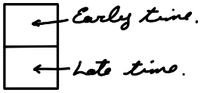
- Start at the source (Early time)
- Choose the LARGEST going forward (Node + edge)
- Choose the SMALLEST going back (Node – edge)

Critical Path Analysis:
- Draw a precedence table (dependence table).
- Draw an activity network.
- Start with the source node numbered zero/zero. 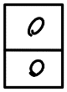
- It may take a few attempts.
- It may include dummy activities (You cannot have 2 edges between nodes).

Gantt’s Charts:
- The top row is reserved for the critical path.
- Float times are represented by dotted lines.

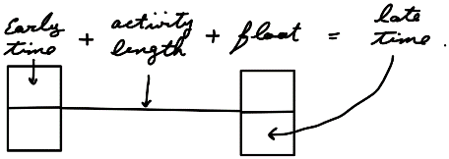

or: The Float time = Late time – Activity length – Early time (working backwards)

Scheduling:
- Use the Gantt’s charts.
- Assign one worker to the critical path.
- Assign the activity with the lowest late time.
- Find the lower bound of the minimum number of workers:
- Divide the total number of hours of the project by the critical time (Critical path)
- There may be reduced number of workers.

Bellman’s principal of Optimality:
- Multi-stage network (State/Action)
- The sum of weights on a sequence of actions is called the value.
- Optimal value.

Dynamic programming for a multi-stage problem:
- Draw a table with the following: Stage, State, Action, Destination, Value.
- Start at the sink node and work back.
- Find the optimal value for each state (Vertex) at the start of that state.
- Asterix.
- Continue to the source.
- Use the Asterix to read off the optimal path.
- These are sometimes given in table format.
- You need to know:
- Rounding problems
- Stock control problems.
- Allocation of resources problems.
- Equipment replacement and maintenance problems.

